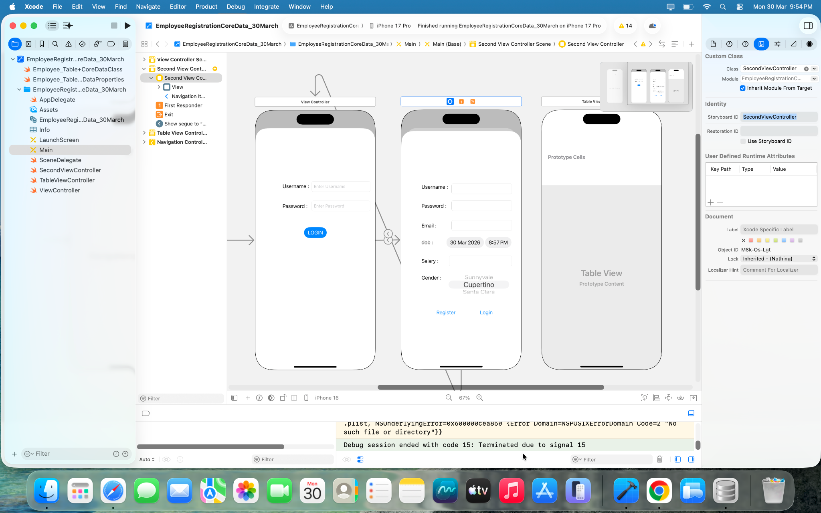

//
// ViewController.swift
// EmployeeRegistrationCoreData_30March
//
// Created by apple on 30/03/26.
//
import UIKit
import CoreData
class ViewController: UIViewController {

@IBOutlet weak var username: UITextField!

@IBOutlet weak var password: UITextField!

override func viewDidLoad() {
super.viewDidLoad()
let filepath = FileManager.default.urls(for: .applicationSupportDirectory, in: .userDomainMask).first
print(filepath!)
// Do any additional setup after loading the view.
}
@IBAction func BtnLogin(_ sender: UIButton) {
if username.text == "" || password.text == "" {
alertFail()
return
}
let AppDel = UIApplication.shared.delegate as! AppDelegate
let ctx = AppDel.persistentContainer.viewContext

let request = NSFetchRequest<Employee_Table>(entityName: "Employee_Table")

do{
let data = try ctx.fetch(request)

var isFound = false
for item in data {
if item.username == username.text && item.password == password.text {
isFound = true
break

}
}
if isFound {
alertSuccess()
} else {
alertFail()
}
}catch{
print("Error",error.localizedDescription)
}
}

func alertSuccess() {
let alert = UIAlertController(title: "Login", message: "Success", preferredStyle: .alert)
alert.addAction(UIAlertAction(title: "OK", style: .cancel,handler: { _ in

let sb = UIStoryboard(name: "Main", bundle: nil)
let next = sb.instantiateViewController(withIdentifier: "SecondViewController")
self.navigationController?.pushViewController(next, animated: true)

}))
present(alert,animated: true)
}

func alertFail(){
let alert = UIAlertController(title: "Login", message: "Failed", preferredStyle: .alert)
alert.addAction(UIAlertAction(title: "OK", style: .destructive))
present(alert,animated: true)
}
}

//
// SecondViewController.swift
// EmployeeRegistrationCoreData_30March
//
// Created by apple on 30/03/26.
//
import UIKit
import CoreData
class SecondViewController: UIViewController,UIPickerViewDelegate,UIPickerViewDataSource {
func numberOfComponents(in pickerView: UIPickerView) -> Int {
return 1
}

func pickerView(_ pickerView: UIPickerView, numberOfRowsInComponent component: Int) -> Int {
return genderlist.count
}

func pickerView(_ pickerView: UIPickerView, didSelectRow row: Int, inComponent component: Int) {
selectedGender = genderlist[row]
}

func pickerView(_ pickerView: UIPickerView, titleForRow row: Int, forComponent component: Int) -> String? {
return genderlist[row]
}
@IBOutlet weak var dob: UIDatePicker!
@IBOutlet weak var email: UITextField!
@IBOutlet weak var password: UITextField!
@IBOutlet weak var Username: UITextField!
override func viewDidLoad() {
super.viewDidLoad()
// Do any additional setup after loading the view.
}
var selectedGender = ""
let genderlist = ["Male","Female"]

@IBAction func BtnRegister(_ sender: UIButton) {
let AppDel = UIApplication.shared.delegate as! AppDelegate
let ctx = AppDel.persistentContainer.viewContext
let obj = Employee_Table(context:ctx)

let dt = DateFormatter()
dt.dateFormat = "dd/MM/yy"
let selecteddob = dt.string(from: dob.date)
obj.dob = selecteddob
obj.empid = UUID()
obj.email = email.text!
obj.password = password.text!
obj.username = Username.text!
obj.gender = selectedGender
do{
try ctx.save()
print("Inserted")
}catch{
print("erorr",error.localizedDescription)
}
}
/*
// MARK: - Navigation
// In a storyboard-based application, you will often want to do a little preparation before navigation
override func prepare(for segue: UIStoryboardSegue, sender: Any?) {
// Get the new view controller using segue.destination.
// Pass the selected object to the new view controller.
}
*/
}

